CHEMICAL ENGINEERING TRANSACTIONS  VOL. 96, 2022 | A publication of
The Italian Association
of Chemical Engineering
Online at www.cetjournal.it

Guest Editors: David Bogle, Flavio Manenti, Piero Salatino
Copyright © 2022, AIDIC Servizi S.r.l.
ISBN 978-88-95608-95-2; ISSN 2283-9216

Cement to safeguard the wells integrity in Underground Hydrogen Storage: an experimental investigation
Vanessa S. Iorioª *, Federico Cracoliciª, Fabio Parrozzaª, Luigina M. F. Sabatinoª, Elisabetta Previde Massaraª, Alberto Consonniª, Chiara Trittoª, Michela De Simoniª
ªEni S.p.A, San Donato Milanese (MI), Italy
vanessa.silvia.iorio@eni.com
Eni, like all the Energy companies, aims to accelerate the reduction of its carbon footprint by implementing the best applicable low-carbon solutions, and hydrogen is surely playing a fundamental role.
Hydrogen is the simplest and most abundant element on the planet and an energy vector that has shown great promise worldwide as a solution for meeting climate challenges. This is because it can store and supply large quantities of energy without producing CO₂ emissions during combustion. Once produced, the hydrogen needs to be stored for later consumption and here it becomes clear that the importance of Underground Hydrogen Storage (UHS) rises significantly. The main goal of any company is to find all the possible synergies with current activity and business. Even though injection in salt caverns has unquestionable benefits, hydrogen injection in depleted oil and gas reservoirs could be the solution to maximize efficiency and implement a circular economy approach.
From an engineering point of view, before developing any Underground Hydrogen Storage (UHS) project, the first step is to analyze and study all the challenges related to this activity. Well suitability must be guaranteed during all the reinjection, in the following document a detail of this topic and especially of one of the main elements that have the role to safeguard the integrity of the well, which is the cement. This document aims to analyze the interaction of standard cement slurries used in oil and gas fields with hydrogen at standard reservoir conditions. The cement-hydrogen interaction tests shown in this document were conducted using autoclave as key instrumentation to simulate reservoir temperature and pressure conditions. The tests were designed and conducted using the methodological approach typical of the materials/fluids compatibility tests.
Preliminary autoclave experimentation results show that hydrogen does not alter the chemical and physical characteristics of cement samples.
This compatibility study of hydrogen is the first important step to further de-risk activities, the assurance of well integrity is critical and important in all stages to avoid any loss uncontrolled of hydrogen.

Introduction
Generally, UHS in depleted reservoirs is easy to develop, operate and maintain due to the already existing infrastructure with proven integrity (Muhammed et al., 2021). However, hydrogen interactions in underground gas storage sites (UGS) are a perplexing topic due to their foreign nature and therefore their behavior in the subsurface could be not predictable. In the subsurface, hydrogen can instigate several changes such as and not limited to promoting mineral precipitation and dissolution in cement, reservoir, and caprock. These cases can cause potential integrity issues in the entire UGS. (Boersheim et. al., 2019) Therefore, an investigation is required into cement-hydrogen interaction to quantify and mitigate potential integrity issues of UHS.

Figure 1 – Potential pathways of leakage along the wellbore (Reinicke and Fitcher, 2010)

Figure 2 – Composite cores: metal + cement + reservoir rock (Boersheim et. al., 2019)

From literature, it results that H₂ migrations into cement cores are not critical due to the presence of water inside cement pores and hydrogen low solubility in water. Moreover, cement alteration due to H₂ reaction is not favoured.
In the previous experiments Boersheim et. al., 2019, composite cores (metal + cement + reservoir rock) and cylindrical class G cement cores, placed in high saline synthetic brine, were exposed in an autoclave at 80 °C and 50 bar for 4 weeks to hydrogen atmosphere.
For comparison, cement plugs were exposed to nitrogen. The results of this experiment were that both gases had a minimal to no effect, furthermore, cement G samples exposed to hydrogen showed similar changes in porosity and permeability values.
Thermodynamic interaction with the main cement components
The first step of the study aimed to evaluate the interaction between main cement components and hydrogen through a thermodynamic stud.
In this study class G Cement was analysed, of which the main components are:
- Anhydrous phases - C₃S: tricalcium silicate, C₂S: dicalcium silicate, C₃A: tricalcium aluminate, C₄AF: Tetracalcium aluminoferrite
- Hydrated phases – CSH: calcium silicate hydrate, Portlandite Ca(OH)₂, Ettringite (Ca₆Al₂(SO₄)₃(OH)₁₂•26(H₂O) and Katoite (Ca₃Al₂(SiO₄)_{1.5}(OH)₆).
It is believed that H₂ migration inside cement pores is not a critical issue owing to its low solubility in the water present inside pores. On the other hand, as with other gases, H₂ migration inside cement pores may be prevented by adding chosen organic polymers (Nelson, 1990).
Experimental tests reported in the literature have been carried out for a limited period (usually 4 weeks) and nowadays long-time behaviour is not well known.
Long contact time, even assuming a very low H₂ solubility in water, could expose cement components to hydrogen, that together with temperature and pressure, may cause H₂-cement chemical reaction. Besides the effect of H₂, in some cases, bacteria may promote H₂S formation that can act on cement components (Fakhreldin, 2012).
Redox reaction of Iron and or Aluminium species present in cement composition, by hydrogen are high energy demanding reactions but, the presence of other species may act as catalyst and redox reaction may occur.
To evaluate such a possibility, from a theoretical point of view, in the function of H₂ concentration and temperature values, thermodynamic studies have been carried out.
The results are reported as Gibbs Free Energy (ΔG) data.
If ΔG is positive, the reaction is nonspontaneous (i.e., the input of external energy is required for the reaction to occur) and if it is negative, the reaction is spontaneous and occurs without external energy input.
The reaction between Hydrogen and Fe₂O₃ (Ferric oxide, hematite) can lead to Fe₃O₄ (Ferrous-Ferric oxide, magnetite), as a first step (Sun et al., 2020). From H₂-Fe₃O₄ reaction FeO and/or Fe may form.
For completeness, evaluation has been performed even for direct formation of FeO and/or Fe from Fe₂O₃. In such a case reduction to metallic iron is less favoured than the formation of partially reduced FeO product. In the 50-300°C temperature range, for both products, ΔG is positive, consequently reaction between Hydrogen and Iron oxides cannot easily occur. At higher temperature values (300-1500°C) only redox reaction to FeO may result spontaneously (see Table 2). In such a case Gibbs Free Energy starts to be negative around 1100°C.
T (°C) | Fe₂O₃ + 3H₂ = 2FeO + 3H₂O | Fe₂O₃ + H₂ = 2Fe + H₂O
50 | 1.606 | 9.109
100 | 1.930 | 11.529
150 | 2.200 | 13.823
300 | 2.767 | 20.030
600 | 2.681 | 28.390
800 | 1.971 | 31.241
1100 | -0.102 | 32.076
1500 | -5.364 | 28.630
Table 1 - Gibbs Free Energy for Fe₂O₃/H₂ reaction as function of temperature
As reported in Table 1 direct reactions from Fe₂O₃ to FeO and/or Fe are not spontaneous and consequently, they may not occur. In Figure 3 the ΔG (Gibbs Free Energy) for magnetite formation from hematite is reported (data have been collected in 50-1500 °C range, but in the figures only 50-300°C range is reported). ΔG values for further reaction steps are also reported on the right in Figure 3.
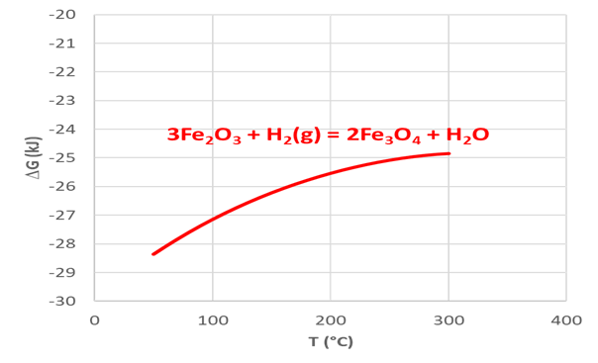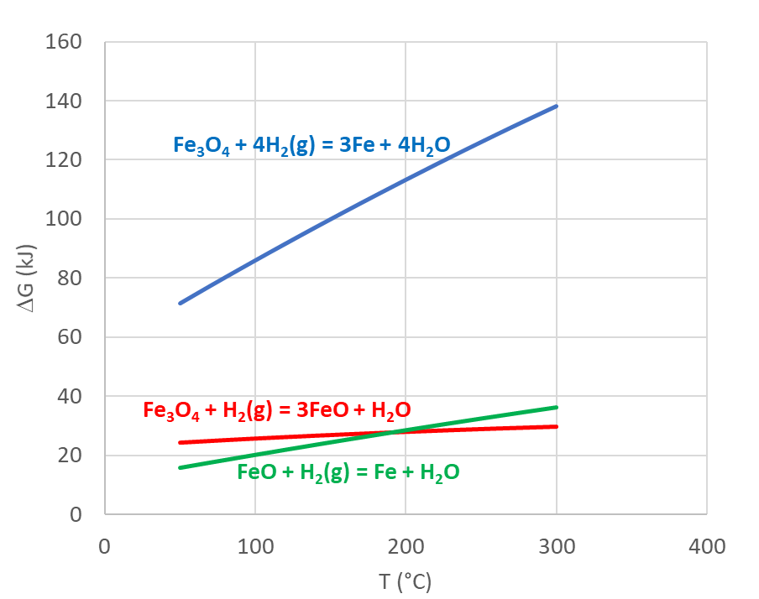
Figure 3 - Gibbs Free Energy for Fe₂O₃/H₂ (left) and Fe₃O₄/H₂ (right) reaction in the range 50-300°C
The most probable reaction between Fe₂O₃ and hydrogen is the formation of Fe₃O₄. As reported in Figure 3, Gibbs Free Energy, in 50-300°C range is negative indicating a spontaneous reaction.
The reaction Fe₂O₃/H₂ could lead to metallic iron in two steps: the first step to FeO formation and the second from FeO to Fe. As reported in the following scheme reaction from FeO to Fe is not spontaneous in all studied temperature ranges.
As result of reported data in Figure 4, the interaction between Fe₂O₃ and H₂ can lead to FeO formation only at very high-temperature values and the formation of metallic Fe cannot easily occur.
On the other hand, Fe₂O₃ can transform into Fe₃O₄ very easily in the temperature range studied.
Further reduction reactions to FeO and Fe are not so easy to occur if other parameters are not present. An important parameter could be the presence of a species that can act as a catalyst that decreases activation energy for all reactions.

T (°C) | FeO + H₂(g) = Fe + H₂O
50 | 3.751
100 | 4.799
150 | 5.812
300 | 8.631
600 | 12.854
800 | 14.635
1100 | 16.089
1500 | 16.997
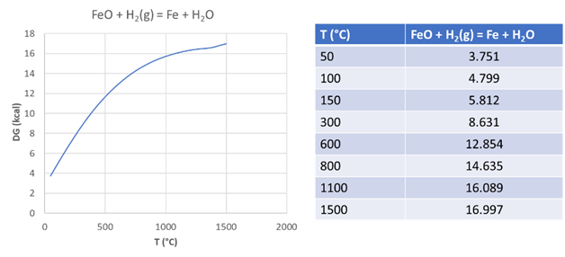
Figure 4 – Reaction from FeO to Fe Table 2 - Gibbs Free Energy for FeO/H₂ reaction as function of temperature
In conclusion, the reaction that cement can undergo in presence of Hydrogen is partial Fe₂O₃ reduction to Fe₃O₄. Considering the low amount of Fe₂O₃ cement matrix and the temperature range for H₂ (less than 100 °C) storage, the potential reduction of Fe₂O₃ to Fe₃O₄ should not impact cement resistance and sealing capacity. More information on the cement stability could be obtained by performing experimental tests and by characterization of the specimen after interaction with Hydrogen.
Testing Methodology and Sample Selection
The cement-hydrogen compatibility tests were focused on the analysis and comparison of the physico-chemical characteristics of the cement samples pre-and post-exposure to hydrogen itself under well conditions.
The testing involved the static exposure to the hydrogen of two types of cement in two separate batches.
The identified cementitious slurries, which are currently mostly used in the casing primary cementing jobs in production phases of the O&G wells, are respectively:
- 1° Batch, Cement slurry with API class G HSR cement.
- 2° Batch, Cement slurry with a blend of API class G HSR cement + Silica 35% by weight of cement.
The slurries were chosen with the least possible number of additives and without specific additives for the functional enrichment of the slurry (e.g. gas block additive, expanding additive, ...). In this way, it was possible to better evaluate, specifically for mineralogy, the interaction between hydrogen and the main constituents of the cement sample.
The cement slurries were prepared and characterized according to the API RP 10B-2 standard and left to cure at the chosen temperature for 28 consecutive days. This extensive curing of the cement was aimed at obtaining the complete hydration of the cement, the maximum development of mechanical strength, and achieving the lowest possible porosity and permeability.
For each aging batch, the samples were left inside the autoclave for 8 weeks, in contact with hydrogen only in "dry" conditions (not "wet", i.e. immersed in a liquid) at a temperature condition of 90 °C and the maximum pressure that can be maintained by the instrumental set-up equal to 150 bar.
To ensure the correct humidity rate inside the autoclave, a small amount of distilled water was left on the bottom of the autoclave during the entire aging, without direct contact between the water and the samples.
In parallel to the H₂ aging, twin samples were also aged in nitrogen at the same humidity and T&P conditions.
In Figure 5, the breakdown of the samples for performed tests is reported, to fulfill the physico-chemical characterization:
- Unconfined Compressive Strength Measurement, performed with the mono-axial hydraulic press for the evaluation of the variations of the mechanical properties of the sample.
- Measurement of porosity and gas permeability, performed with an automated gas permeameter to measure the variation in the hydraulic sealing capacity of the sample.
- Measurement of electrical conductivity, performed using an impedance analyzer to determine the variation in sample saturation.
- Complete Mineralogical and Chemical Analysis, performed using X-ray powder Diffraction (XRD), X-Ray Fluorescence (XRF), and Scanning Electron Microscopy (SEM) to observe the variation of the cement phases making up the samples and their morphology.

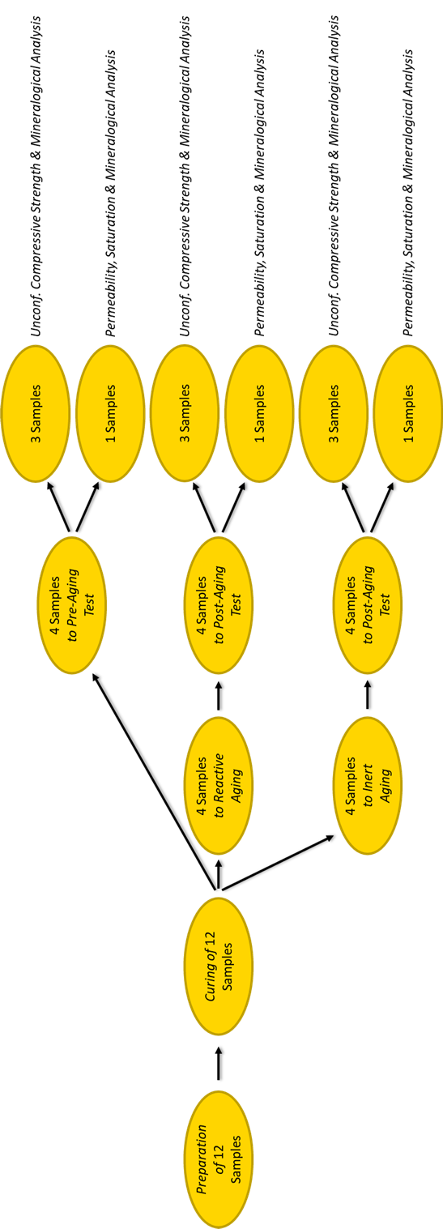
Figure 5 – Samples breakdown for each test batch
Testing Results
The evaluation of the physico-chemical variations of cement depending on the exposure to hydrogen starts from visual observation of the samples and the measurements of dimensions and weight.
After exposure to both gases, cement samples of both batches appear to have the same average values ​​of diameter, length and weight, thus maintaining their density and resulting macroscopically unaltered.
From Figure 6a it is possible to see how the samples of the two batches are identical before and after exposure to hydrogen and do not show cracks or new surface pores; the color change that can be seen is attributable to the humidification of the samples just extracted from the autoclave.
The petrophysical values recorded ​​(permeability and electrical conductivity) are very close to the lower instrumental limits, therefore, to evaluate the petrophysical alterations of the sample it is necessary to take into account the order of magnitude of these measurements and not directly the exact value provided by the instrument. Plotting the results of electrical conductivity and gas permeability in a bi-logarithmic graph (Figure 6b), it is possible to note how the post-exposure points remain within the areas with the same order of magnitude as the baseline points.
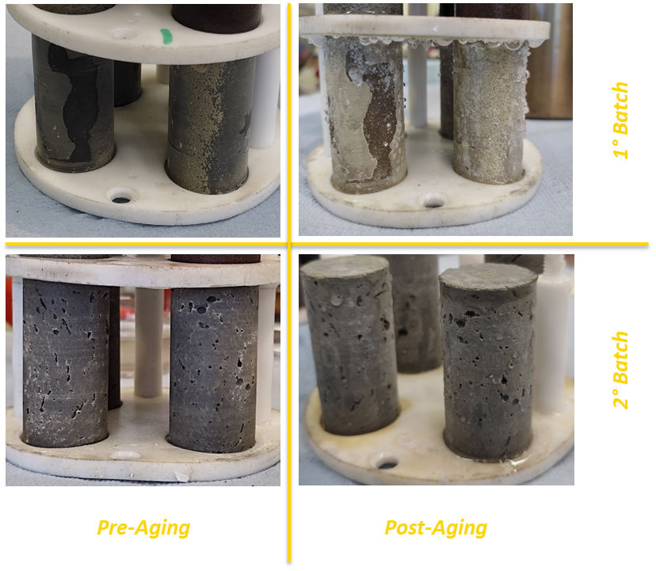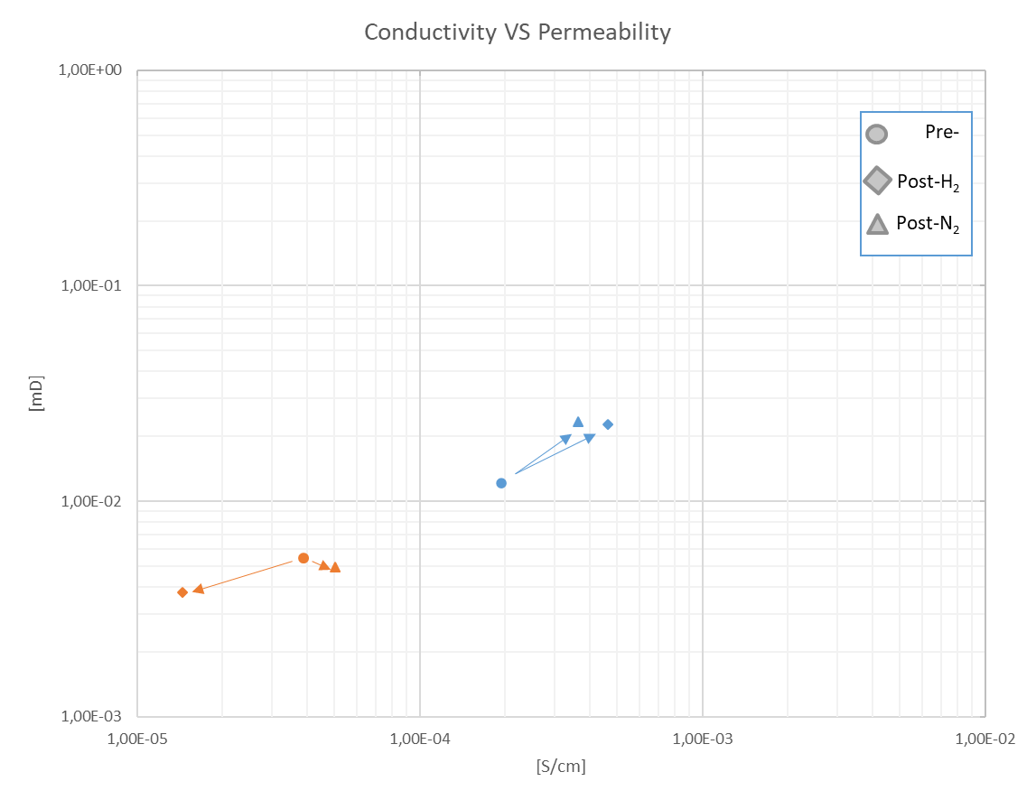
Figure 6a (on left) – Visually unaltered samples after exposure to hydrogen
Figure 6b (on right) – Conductivity VS Permeability graph, blue lines for 1° batch and orange lines for 2° batch
Regarding the mechanical properties, as can be seen from Figure 7, both batches of cement samples it has the same behavior: the variation concerning the baseline is approximately the same in percentage whether the sample has been exposed to hydrogen or nitrogen (-10,7 % for 1° batch and +29,3 % for 2° batch).
Table 3 shows the mineralogical composition of the cement samples of the two batches obtained from XRD-XRF analysis. Given that cement is strongly characterized by amorphous or microcrystalline phases, the data shown in the table are the result of an optimization performed with Eni-proprietary software (Previde Massara et al., 2019).

[%] | C2S | C4AF | Portlandite | CSH1 | CSH2 | Katoite | Ettringite | Quartz
1° Pre- | 9,63 | 12,76 | 25,90 | 44,57 | 0,00 | 3,50 | 3,64 | 0,00
1° Post-H2 | 9,74 | 12,60 | 25,60 | 42,15 | 0,00 | 5,10 | 4,81 | 0,00
1° Post-N2 | 6,61 | 12,41 | 26,10 | 45,92 | 0,00 | 4,90 | 4,06 | 0,00
2° Pre- | 0,50 | 7,58 | 0,00 | 0,00 | 61,32 | 0,00 | 3,08 | 27,53
2° Post-H2 | 1,10 | 6,53 | 0,00 | 0,00 | 62,89 | 0,00 | 2,69 | 26,80
2° Post-N2 | 0,70 | 7,25 | 0,00 | 0,00 | 61,41 | 0,00 | 3,34 | 27,30
Table 3 – Percentage mineralogical composition of pre-and post-exposure cement samples
For each batch, the chemical compositions of samples related to the pre-and post-gas exposure remain the same. Despite the long maturation times imposed, the tested samples still show a small percentage of anhydrous phases, while the hydrated phases are in line with what was expected from the literature: SiO₂ particles added in the cement slurry can transform the portlandite phase to more stable phase of calcium-silicate-hydrate (Richardson 2008).
The significant amount of unreacted SiO₂ in the second batch is attributable to the low maturation and aging temperature; usually, the SiO₂ is added when operating at temperatures of well above 140 °C, to use the mechanism reported above and mitigate the cement strength retrogression (Eilers and Root, 1976).
This unreacted SiO₂ could also have acted as discontinuity points in the cement matrix of the 2° batch causing the low mechanical strengths measured.
It is very important to underline that all the results obtained (especially for mechanical and petrophysical properties) must be argued about the heterogeneity of the samples, related to the nature of cement itself and the mixing-curing procedure.
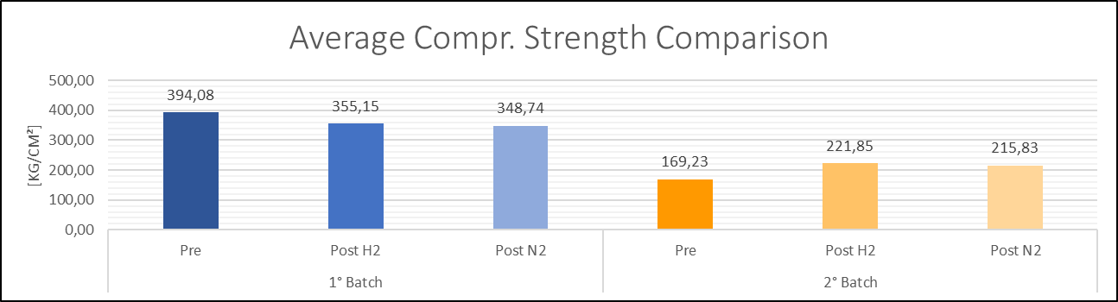
Figure 7 – Average Compressive Strength Comparison, blue lines for 1° batch and orange lines for 2° batch
Conclusions
The preliminary autoclave experimentation results shown in this paper highlight that hydrogen does not alter the characteristics of cement, thus acting in the same way as inert gas for the cement itself.
Studies with different simulated well conditions, contact with aging fluxes and longer exposure times could support the enrichment of the collected data and broaden knowledge on the subject, as well as the results of this study should be scaled to well size and reviewed according to the pressurization cycles for H₂ storage.
This compatibility study of hydrogen with cement as wellbore barrier is the first important step to further de-risk activities (the sentence is too vague, please clarify and further discuss).
References
Boersheim E.C., Reitenbach V., Albrecht D., Pudlo D., Ganzer L., 2019, Experimental Investigation of Integrity Issues of UGS Containing Hydrogen, SPE-195555-MS, Society of Petroleum Engineers.
Eilers L.H., Roots R.L.,1976, Long-Term Effects of High Temperature on Strength Retrogression of Cements, SPE-5871, Society of Petroleum Engineers.
Fakhreldin Y., 2012, Durability of Portland Cement with and without Metal Oxide Weighting Material in a CO₂/ H₂S Environment, SPE-149364-MS, North Africa Technical Conference and Exhibition.
Nelson E.B., 1990, “Well Cementing”, Elsevier Science Publisher - Schlumberger, Amsterdam
Previde Massara E., Consonni A., Pessina R., Casali P., Floriello D., Amendola A., 2019 - Integrated Mineralogical Analysis (IMA) in rock characterization – 14th Offshore Mediterranean Conference and Exhibition in Ravenna, Italy OMC-2019-1069
Reinicke K.M., Fichter C. 2010, Measurement Strategies to Evaluate the Integrity of Deep Wells for CO₂ Applications, Sino-German Conference on Underground Storage of CO₂ and Energy.
Richardson I.G., 2008, The calcium silicate hydrates. Cement and Concrete Research 38(2), 137–158
Sun G.,Li B., Yang W.,Guo J., Guo H., 2020, Analysis of Energy Consumption of the Reduction of
Fe₂O₃ by Hydrogen and Carbon Monoxide Mixtures, Energies MDPI
Tritto C., De Simoni M., Roccaro E., Pontiggia M., Panfili P., del Gaudio L., Visconti L., Iorio V. S., dell’Elcea, 2022,G.Underground Hydrogen Storage in depleted gas reservoirs: opportunity identification and project maturation steps, CEt Chemical Engineering Transactions – AIDIC

